jBPM Introduction

What is jBPM?

jBPM stands for Java Business Process Management. It is a flexible business process management suite which is written in Java language. It is light-weight and fully open-source in nature. It allows us to create, deploy, execute and monitor business processes throughout their life cycle. It fills the gap between the business analysts and developers. It is distributed under the **Apache license**and was released under the **ASL** by the **JBoss** Company.

What is Business Process?

A Business Process is a set of activities which follows the number of steps in a specific order to fulfil the organizational goals. The order of these goals are depicted using a flowchart. These processes can significantly improve the visibility and agility of our business logic.

Every Business Process needs to be supported throughout their entire life-cycle. These life-cycle includes: authoring, deployment, process management & task lists and dashboards & reporting.

Here is a graphical flowchart example which helps you to understand the Business Process easily.

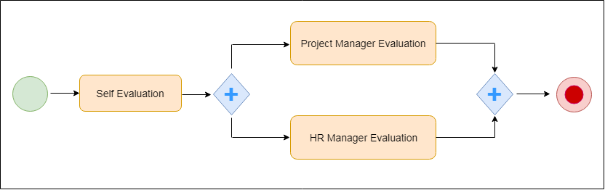 

The above process takes place in the following order:

* First, the employees self-evaluate themselves and submit these self-evaluated report to their Project Manager.
* Now, both the Project Manager and HR Manager evaluates their performance and provide a rating on that evaluation.
* At last, the feedback will be provided to an employee.

# jBPM Features

jBPM Features

## The core features of jBPM are:

* Light-Weight
* Support BPMN 2.0
* Support Persistence and Transaction
* UI Tools
* Eclipse-Based and Web-Based
* Rule Engine
* Human Task Services

### **Light-Weight**

jBPM is lightweight, fully open-source and written in Java language.

### **Support BPMN 2.0**

jBPM focuses on **BPMN 2.0** (Business Process Model and Notification) specification as the process definition language. **BPMN 2.0** is a global standard for process modelling and is one of the core components of successful Business-IT-Alignment.

### **Persistence and Transaction**

jBPM supports Persistence and Transactions which is based on the **JPA** and **JTA**.

### **UI Tools**

jBPM has UI tools available in the design phase.

### **Eclipse-Based and Web-Based**

jBPM works on **Eclipse-based** and **Web-Based** editor which provides **drag** and **drop** support for the graphical creation and simulation of our business processes.

### **Rule Engine**

jBPM provides a **Rule Engine** which provides a declarative language that is used to evaluate the available information.

### **Human Task Service**

jBPM uses a pluggable Human Task Service based on the **Web Services Human Task** specification. It includes tasks that need to be performed by humans. It also defines the data structure to store information about the human tasks.